**Rigiccordian-based Origami Worm Robot**

Fall 2024

**ME-400**

**Andrew Carr**

**Dr. Mohammad Hasan**

**Introduction**

As part of ME-400, I worked on redesigning the worm robot for better movement. The previous robot was designed quickly as a proof of concept. It was tedious to assemble and change components, the motors were difficult to control, and things would often break. So, before we focused on movement, the robot was redesigned to fix each of these problems. After this, the focus was realigned on optimizing movement. The friction pads were notoriously inconsistent where sometimes they would work like we expected, sometimes do nothing and sometimes do the opposite of what we expected. Work was focused on trying different sawtooth friction pad designs.

A Bambu P1S was used for all 3D printing.

This report will highlight changes and provide documentation for assembly of hardware and an outline for software design.

The work done on the robot started about halfway through the quarter, the other half was spent on computer vision.

**Table of Contents:**

1. Robot Redesign
2. Robot Control
3. Bill of Materials
4. Worm Assembly
5. Wiring Diagram
6. Appendix

**Robot Redesign**

**Clamp Spring System:**

Previously, the origami spring was attached with tape to the supports. During testing, the spring would slip and was difficult to detach and reattach. A new mechanism was designed to allow quick on/off and one that would hold the spring in place well.

The new system was a clamp that would sandwich the spring between two plastic pieces. The clamp has edges that when fully put together will add extra resistance to coming apart.

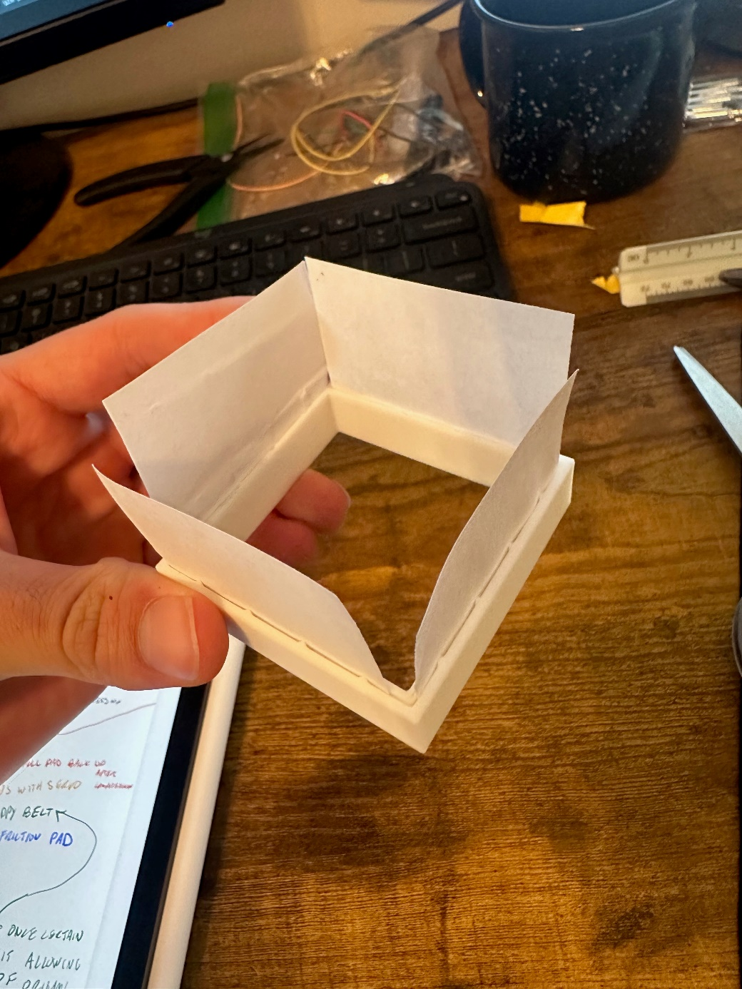

Figure 1. Original test clamp for proof of concept

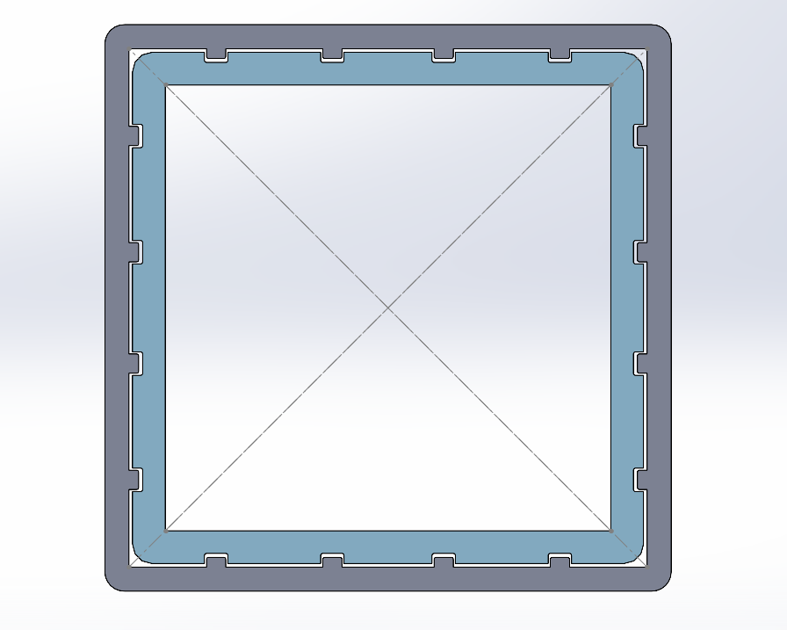

Figure 2. Clamp mating cross-section

**Friction Pad Fast-mounting System:**

Since the new spring attachment system had an outer shell, this opened up the opportunity to add a way to attach friction pads directly. On the old system, friction pads were taped on. The new system used rails on the friction pads that would slide into a slot on the outer shell of the clamp. The rails are 1.3 mm thick, and the slot is 1.5 mm thick.

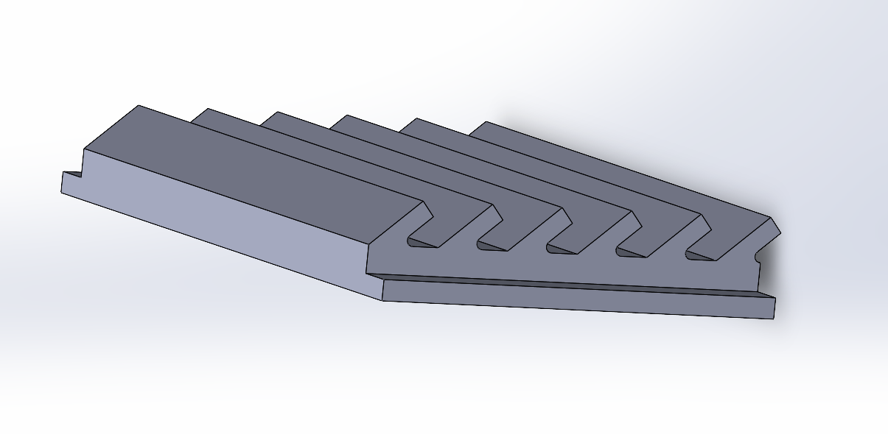

Figure 3. Friction pad with rails

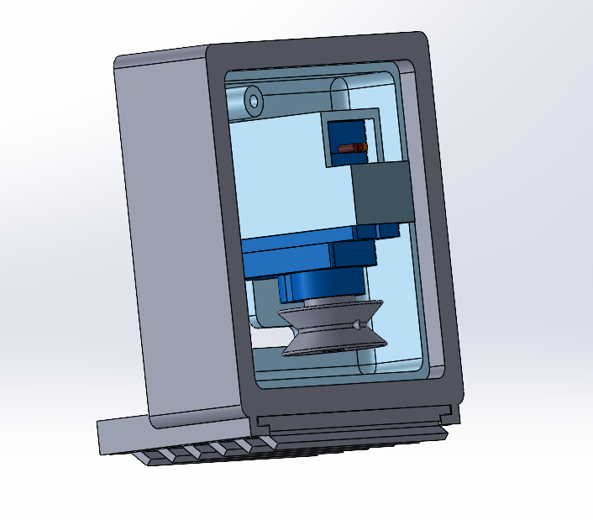

Figure 4. Clamp system with fast-mountain friction pad system

**Servos to DC Motors:**

The original design used continous rotation servos for actuation. These were quick to implement, cheap and in the lab. The servos were small and weak so they sometimes could not compress the asymetrical spring at the same rate. Also, they had a small plastic shaft with a star design. This made it very difficult to 3D print new parts that would couple securely.

The right DC motor could solve all the problems with the servos. We needed a DC motor with an encoder that was strong enough to compress the robot completely. A quick calculation was done to estimate a max torque necessary to hold the robot in full compression and to compress the robot at a rate similar to the previous robot (see Appendix A). Stiffness data was used from the previous paper.

A Pololu micro-geared DC motor was selected. An option with a 298:1 gear ration fulfilled both the torque and speed. This motor was also very small and had an encoder built in.

Figure 5. Pololu Micro Metal Gearmotor ([pololu.com/product/5147](https://www.pololu.com/product/5147))

A Pololu dual motor driver was used to drive the two motors off of one chip.

Figure 6. Pololu DRV8833 Dual Motor Driver ([pololu.com/product/2130](https://www.pololu.com/product/2130))

Since new motors were used, the motor mounts needed to be redesigned. The mounts were designed to be in line with the other sides connection, and were to be as minimal as possible. Also, the mount features a spot for a scew to be screwed in to hold the other side of the tether. There were many different spots for where the tether could be attached.

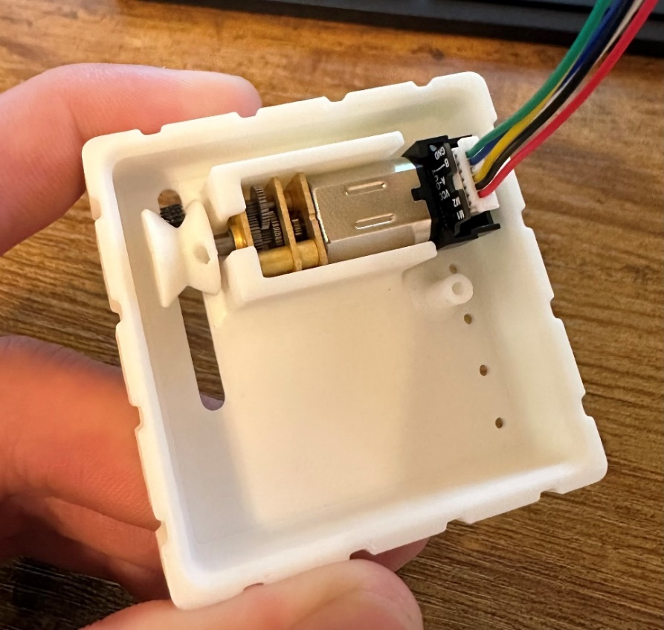

Figure 7. First Iteration Motor Mount Design

**Pulleys:**

Pulleys were designed to fit on the motor shafts and needed to be able to attach the tether well. The pulleys press fit tightly onto the shaft. There is a hole for a screw to lock onto the shaft but the plastic threads do not hold well enough to do anything. The pulley has a hole to tie the tether into.

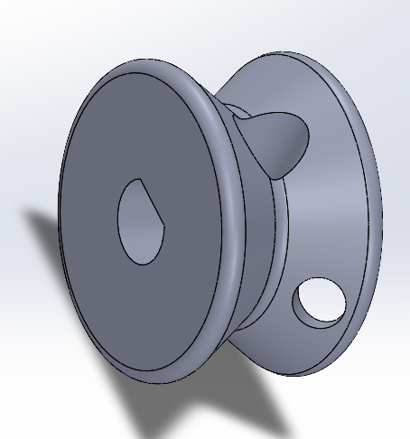

Figure 8. Pulley

**Fully Assembled:**

With all of these changes, the problems with the old robot were fixed. This robot was strong, and it was easy to test new friction pads and worm angles.

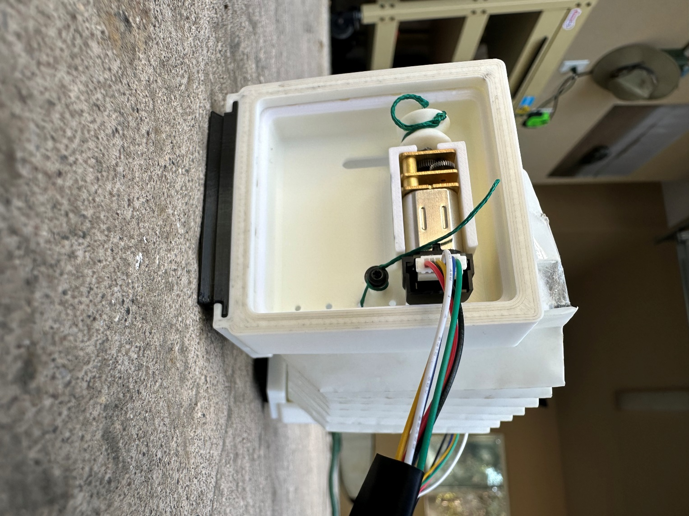

Figure 9. Redesigned Robot fully assembled

**Robot Control**

**User Input:**

Previously, the robot was controlled by a timed sequence. This was easy to implement but without any speed control, the motors would get out of sink and it was hard to reallign them. A way to control the robot live would make the testing and movement much easier.

An analog joystick was used for user input. A plastic joystick was fit to the small metal joystick piece, and a housing was made to hold the joystick and Arduino side by side.

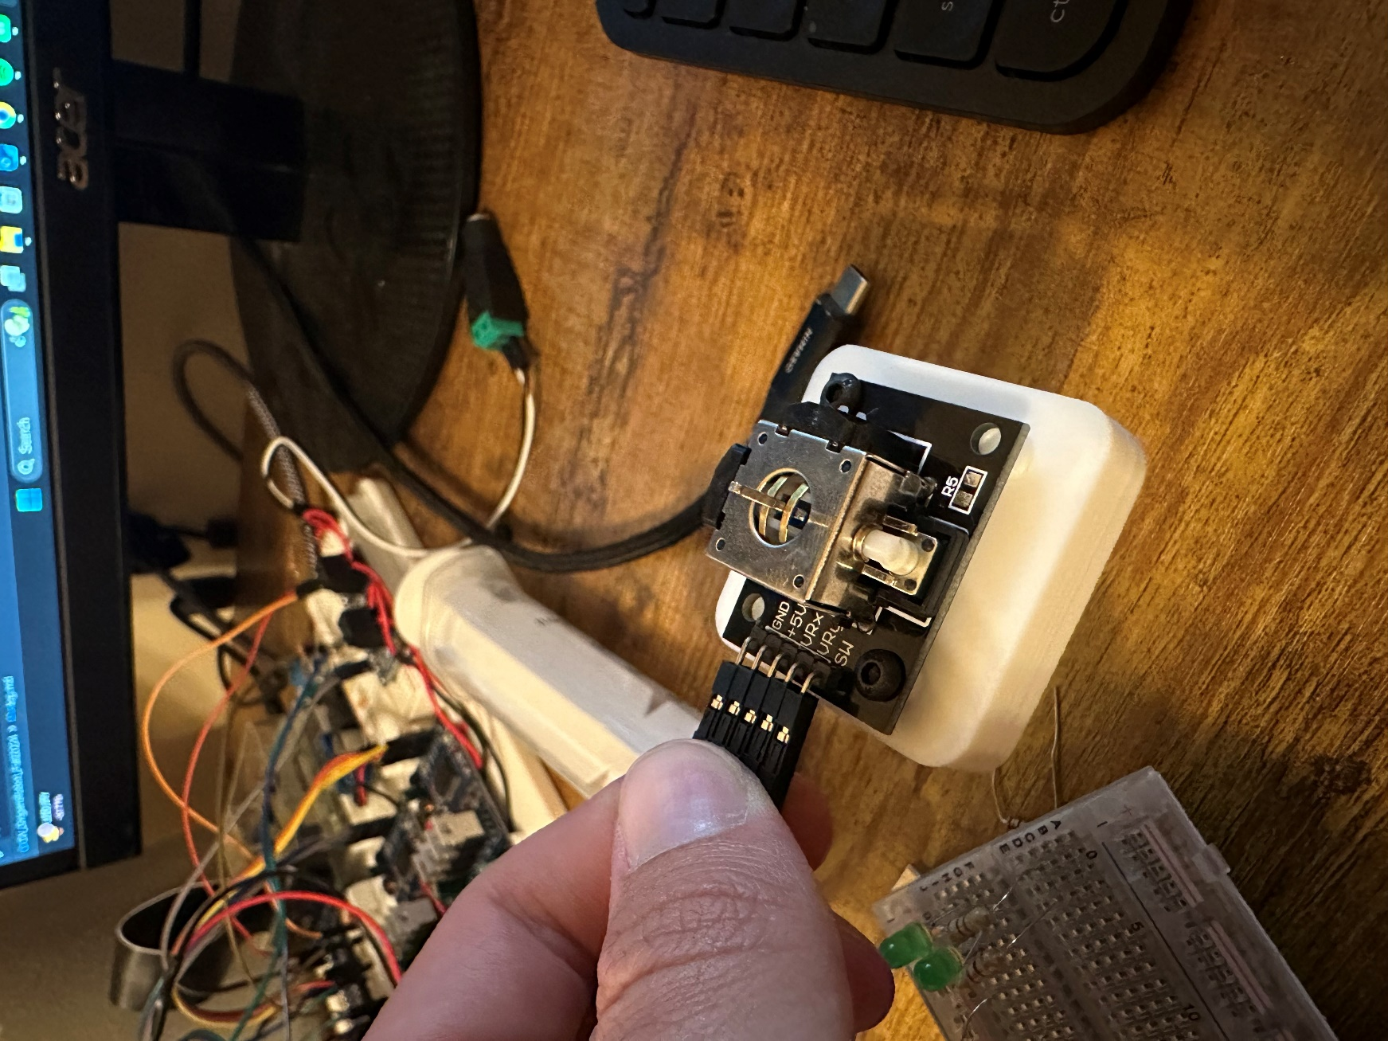

Figure 10. Analog Joystick

Figure 11. Joystick and Arduino Setup

Pushing the joystick forward compresses both motors and vice versa. Pushing it to one side rotates a given motor depending on if its forwards or backwards.

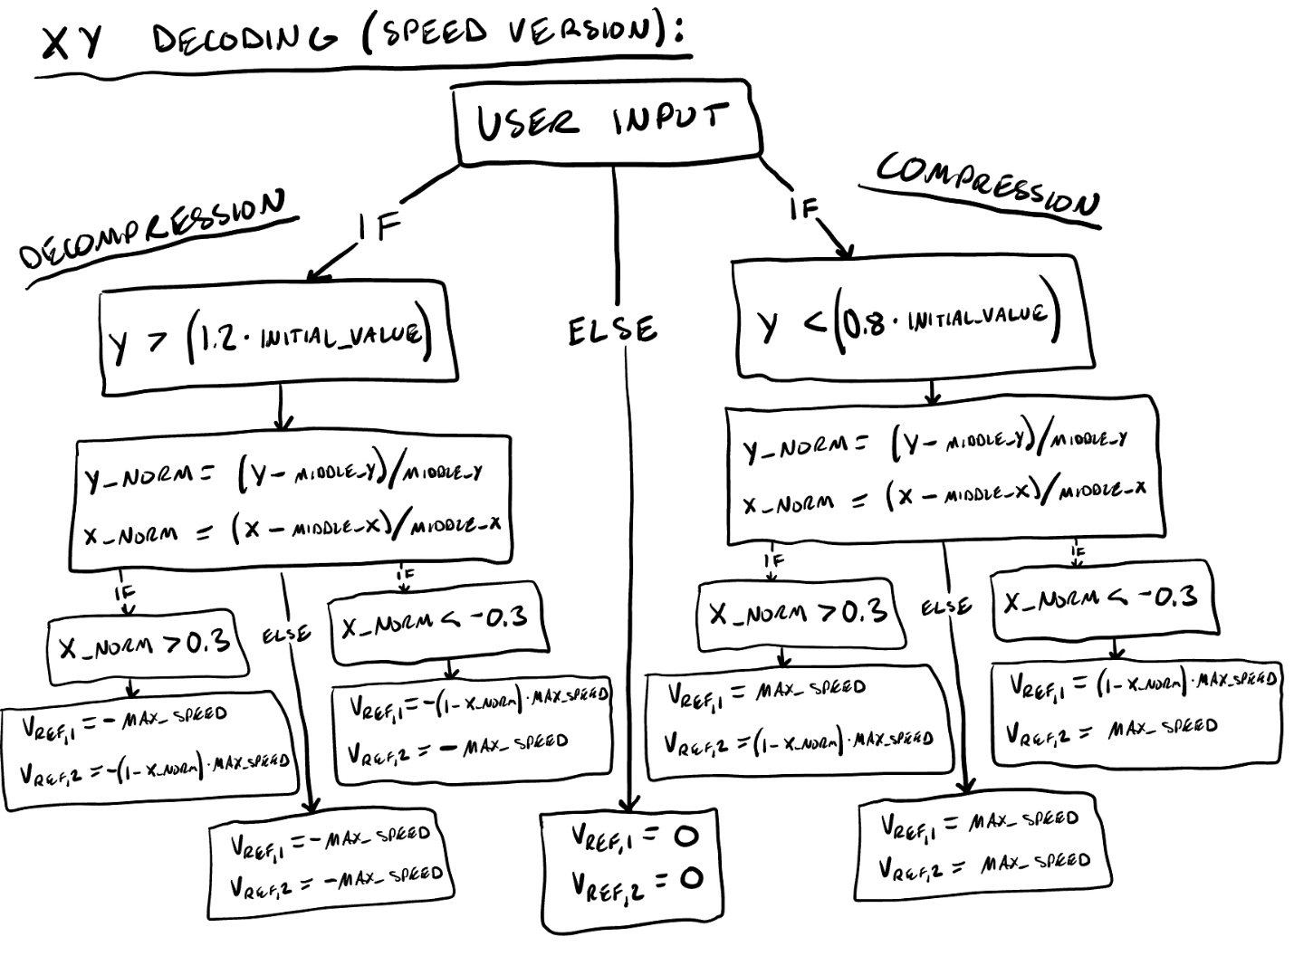

Figure 12: Joystick Decoder

**Controller:**

A speed-based PI controller was used to go to a specifc speed based on how forward the joystick was. If the motors become off, the system corrects this until the motors angles are realligned.

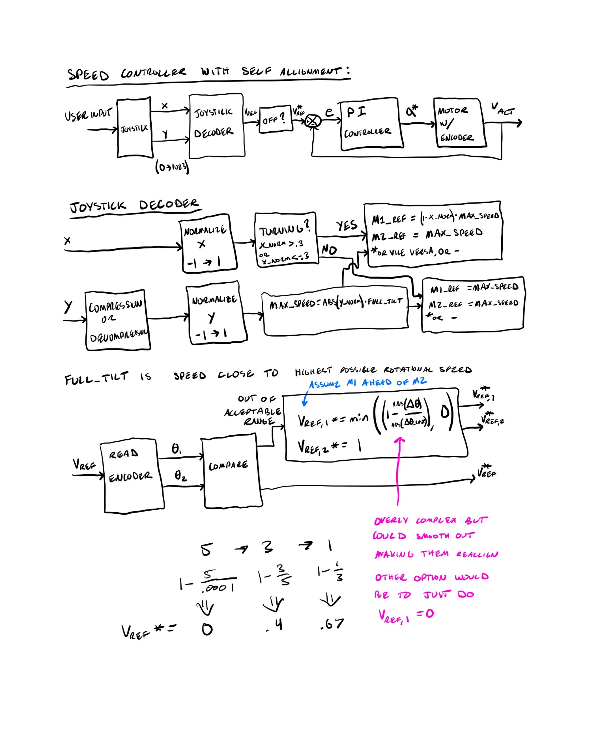

Figure 13. PI speed controller based on joystick inputs

**Movement Results**

Once the new robot was fully working, tests could be completed using different friction pads and worm angles. (to be added)

**Assembly/Wiring**

|  |  |  |  |  |  |
| --- | --- | --- | --- | --- | --- |
| **#** | **ITEM** | **Quantity** | **Price** | **Link** | **Total Price** |
| 1 | Pololu 298:1 Micro Metal Gearmotor | 2 | $25.95 | [www.pololu.com/product/5147](https://www.pololu.com/product/5147) | $51.90 |
| 2 | Pololu DRV8833 Dual Motor Driver | 1 | $9.95 | [www.pololu.com/product/2130](https://www.pololu.com/product/2130) | $9.95 |
| 3 | Arduino Uno R3 | 1 | $29.00 | [www.amazon.com/Arduino-A000066-ARDUINO-UNO-R3](https://www.amazon.com/Arduino-A000066-ARDUINO-UNO-R3/dp/B008GRTSV6/ref=sr_1_1?crid=MNSB3L7O31J7&dib=eyJ2IjoiMSJ9.MazmhFfn-DF8W5oyX_S-tDFAqLRDaMJSkroaZhdQMdi0gDRB833TaFRQwL9_H2cSJbNv7PL-XHTuZseVExgsfw8Kos30ETe0nBIND2ysPDSFrvGuatjcwY-rEQlwH8uC9gRe8ueEZ7A3kq8jP-jDkd_J_XutptQR0or-mAHG73dWnc97BHz5jFQeT27QZV7yTvc0U3lUzqc7LCE2xIRkqoG6Cs66xs5Cr-BkMudeyy_GNgWUgd7B0-X5Cqm2M0vv1SgxsHdBp6kn0HHlx7s3T_1oOftuC5VBXd2qFt-Vi8c.F2DWPCERF_rloCK3Jij0qII1JzImswg5OeEBjOQBFsg&dib_tag=se&keywords=arduino%2Buno&qid=1733718358&s=industrial&sprefix=ardu%2Cindustrial%2C209&sr=1-1&th=1) | $29.00 |
| 4 | Analog Joystick | 1 | $9.99 | [www.amazon.com/Joystick-Controller](https://www.amazon.com/Joystick-Controller-Compatible-Raspberry-PlayStation-2/dp/B0BFQTLM5T/ref=sr_1_4?crid=2B4EO5RSP63X1&dib=eyJ2IjoiMSJ9.IQIJ2xsrkh3klkusZ7j3qa43gA9-mQNZBeDdiFkOBeN4Q1Uo0UMBW7ABzTG-wcNR2JzETJXmjpTQTcX0cJ-E-uCTwFvbjAeIznbTFDhWf5ajoGIQ-pSmC8wl87nQEYuBi4JSKFJKxGJANfHirc7u4uxCxi6SaE0osZ3bzeetY578GhOM2jL1fPQWUqbYc-jJvrjeATNh3FkFmxIBEulGj2mg5HZUXQNOOJ_fCYnM_n-13UTjR4YJrsSqXr5X-955Tn4CzzpQg0rt0nzECdrSMmmLfOYxD_CRsJKjfOFlR0Q.fysZNa50AjOKCUDcbrNE_3w5TKVzB4dAuz7Zz6f1RTo&dib_tag=se&keywords=elegoo+analog+joystick&qid=1733718225&s=industrial&sprefix=elegoo+analog+joystick%2Cindustrial%2C162&sr=1-4) | $9.99 |
| 5 | 6 Pin JST SH 1.0mm | 1 | $9.49 | [www.amazon.com/dp/B0BKSNMC](https://www.amazon.com/dp/B0BKSNMCV4?ref=ppx_yo2ov_dt_b_fed_asin_title) | $9.49 |
| 6 | M1.6 x 3mm | 1 | $5.99 | [www.amazon.com/dp/B0CTMKH2CX](https://www.amazon.com/dp/B0CTMKH2CX?ref=ppx_yo2ov_dt_b_fed_asin_title&th=1) | $5.99 |
| 7 | PLA Filament | 1 | $13.99 | [www.amazon.com/ELEGOO-Filament-Dimensional](https://www.amazon.com/ELEGOO-Filament-Dimensional-Accuracy-Printers/dp/B0D421Q2Q2/ref=sr_1_5?crid=3ULD3CT4B6X5E&dib=eyJ2IjoiMSJ9.MHelaoH7c41HZbj1LqWM6Xf2bhb-7o4AbZFhVW95dSJzIVXCLaEmW5ctxKT2e5ctz0YmAdSDQlYQUFPsAwX0pINmWtR6C_BKgy-tDkZpJTlOzIBuTYFu0_TKFBbhoJIANN94xDUWrUqJY1D6ZENyJom8JwsVX44hol6AwPrOUrkNn25Q5hjeUDpZTH8jzR-aNF54yY89vt8qyA0C4EJhMMZ5Zs9srv1450eSTtqMBaFOVVhRgUh7Q40e3B9N6lJgZL1ARC4otHzJKYIRkNMS7pM1gyDYAzHe6EwsfXwMxl8.0TYw1i2jS2A-zKtzhpOTVGrHpiXpCTIRZ2qpuX2bpl8&dib_tag=se&keywords=Bambu%2BPLa&qid=1733717893&s=industrial&sprefix=bambu%2Bpla%2Cindustrial%2C180&sr=1-5&th=1) | $13.99 |
| 8 | Breadboard Power Supply Module | 1 | $6.99 | [www.amazon.com/DIYables-Breadboard-Supply](https://www.amazon.com/DIYables-Breadboard-Supply-Module-Solderless/dp/B0D2K9M4FB/ref=sr_1_13?crid=2VWL5T7NQZEBZ&dib=eyJ2IjoiMSJ9.-1bwk_YwLsf3uK39uVhN8c3r71bKkGUAV_z38vONjMHnWqmv0_8s5XDvA7wn14A0VWZMmZ3t5bBIUfdrt5bnGAcbJK8scv0Gg_Ags3Q6TEWqcjDL3vDoLA9WvEky3Y_EvCCmEsmwfEkg9fCy50ZsRTSX1mkfTQ9tylQrhuGcDlFWPThDKDHtcSiejIM6UTrNtz2-rsu4oyNaCxKH2UHMPlxMUho6TSAGV6J1jYoq0CnjiOPXwlMjHwn80M3Q-ed_ex_E545Wl544fjx6VBPeEkixNwJ9NWv3V_qZG52JM8I.-To6UJcqUXaYdXGqULKil3Is0hxP2KnH0aSMy8CzCkE&dib_tag=se&keywords=elegoo+breadboard+power+supply&qid=1733718637&s=industrial&sprefix=elegoo+breadboard+power+suppl%2Cindustrial%2C142&sr=1-13) | $6.99 |
| 9 | Breadboard | 1 | $8.79 | [www.amazon.com/Breadboards](https://www.amazon.com/Breadboards-Solderless-Breadboard-Distribution-Connecting/dp/B07DL13RZH/ref=sr_1_1_sspa?crid=5UM9XWQBK6F2&dib=eyJ2IjoiMSJ9.EJy4MqGAcE4id3-Lk-rRbLLeS7s0ryWrm5C9ueqePk_H8fe8eWvsEbkK_E6h79ljy7R_ckkUn-TQ8csjZQlTvztevrj23UBa9jAeKXGmxYnjuBP84bOqUCRt5A316FwfuM33Tq5wLJ7NCU1P126roVkLTvljrt-Gobq4SBH7drnTMphuLfOZL3u5sXQTQt-I7Jki5axTGMB3Z9HH_CDT_Sp_G5mSCHDs_ALUgXolwLn_xEWM2s_T2TAvlkWalEUvLhITnzjIvFRM80nEFqVpMnjBAoLeqh4XfE2-MXNeoOI.93ZULQ2eRv6KmQm8E92dyazNt8YXgYcRuQcV2hfARqQ&dib_tag=se&keywords=breadboard&qid=1733718713&s=industrial&sprefix=breadboard%2Cindustrial%2C238&sr=1-1-spons&sp_csd=d2lkZ2V0TmFtZT1zcF9hdGY&psc=1) | $8.79 |
| 10 | Multicolored Dupont Wire | 1 | $6.98 | [www.amazon.com/Multicolored](https://www.amazon.com/Elegoo-EL-CP-004-Multicolored-Breadboard-arduino/dp/B01EV70C78/ref=sr_1_3?crid=11G3B3QIF7ZP1&dib=eyJ2IjoiMSJ9.tjHxIQLJsk16_0YVtUGN6eY5DcByK_7UqHuaN27c6YMU17mKSyiMurztSGmE2Cu38lwv9w0OHoQ35zYMcXkC8b_HDk182zt5n8kOJb8MujGXyAw4yAWbJ9IH6911n6Bw-dGYi9tcQ0jDIgRqy6t3g4tcuA4Vd4jMkR7z4aBD98CruQG0sBWApHarfFTKS0HmNBiawy6K8EYM365xruGTcDHG0c3nhR5QrtTt2Alv-80.DrCcj5En_m-aoMp5jEuFxXxwnEiroF_VRfBI0QL61KY&dib_tag=se&keywords=jumper%2Bwires%2Bbreadboard&qid=1721945778&sprefix=jumper%2Bwires%2B%2Caps%2C136&sr=8-3&th=1) | $6.98 |
| 11 | Machine Screw Assortment Kit | 1 | $25.99 | [www.amazon.com/Machine-Assortment-Metric-](https://www.amazon.com/Machine-Assortment-Metric-Washers-Button/dp/B0C3926M1B/ref=sr_1_1_sspa?crid=2VZI3E8M4P3QM&dib=eyJ2IjoiMSJ9.lsdAn_zaGrdh5ywVod3Jf2uF8wzPxr1FkBqZflwouv3pDKLBKqUfI4DprBcP27dUUpcGFtrCzl8-c88K5k7474H21il7YqmVD4cj3yYqznCxmGdMxbXOVX5jmLj3r2HDec46noXLQ42OWYZdN-LGjm06Huu-Tk_oQhv8YOgQ6rJvR1okMrCZIc3oYSbXDsC3XdaGMb7PwTD4a-LNxx0DczlpTfJ5Y6OCTUSFfn5gmN0.K_1P8jJI8VjRzP2pbtrzDTXHY78cMwanpQ-1KC9qX9g&dib_tag=se&keywords=assorted%2Bmetric%2Bmachine%2Bscrews&qid=1718736451&sprefix=metric%2Bassorted%2B%2Caps%2C110&sr=8-1-spons&sp_csd=d2lkZ2V0TmFtZT1zcF9hdGY&th=1) | $25.99 |
|  |  |  |  |  | $179.06 |

**Bill of Materials:**

**Worm Assembly:**

1. Put DC motors onto inner housing
   1. Put pulley wheel on the motor shaft the mininum amount such that the motors can still fit into the housing. The hole for the tether should be further away from the motor
   2. Screw in the 2 M1.6 screws attaching the motor to the housing.
      1. This is at an awkward angle but just need the right screw driver and some time
   3. Pull pulley wheel all the way onto the shaft and allign with the tether slot
   4. Repeat for 2nd motor
2. Tie tether to hole on each pulley
3. Pull out enough fish line so that it will make it to the other side of the robot with some extra to screw it into place
4. Put housing together
   1. Orient inner housing so that the pulley is sitting in the top left if it was sitting upright
   2. For the first side, bring the origami spring around the housing so that the one piece that sticks up is on the top, and make sure the tether is through the spring to the other side
   3. Bring first tether through the small holes on opposite side inner housing. Repeat this for the other housing. After this step, both inner housings should be in the spring with their tether through the opposite housing
   4. Allign outer housing so that the friction pad rail system is on the bottom and the slot for the part of the spring that sticks up will fit. There is one outer piece for each because the piece that sticks up is assymetrical
   5. Carefully bring the two pieces of housing together and ensure that the spring is staying around the inner housing while the outer housing goes into place
   6. Completely push the two pieces of housing together. You may need to deform origami spring to get the right leverage point
5. Screw tether into place
   1. Orient pulley wheel so that the point where the tether is tied is away from the housing
   2. Screw the M2x8mm into the slot with one washer but leave about 2 mm of space for the tether
   3. Pull on the tether from other side and wrap it around the screw
   4. While holding the tether in place, finish screwing the screw down all the way to lock the tether into place

**Wiring Diagram:**

**Appendix:**

[A] Motor Torque and Speed Calculation

